**31 Filters (profile creators/finding matches)**

________________________

**Here are the filters and their options**

**RELIGION: [profile creators select one; finding matches select up to 3]**

1. Christianity
2. Islam
3. Nonreligious (Secular/Agnostic/Atheist)
4. Hinduism
5. Chinese traditional religion
6. Buddhism
7. Primal-indigenous
8. African traditional and Diasporic
9. Sikhism
10. Juche
11. Spiritism
12. Judaism
13. Bahai
14. Jainism
15. Shinto
16. Cao Dai
17. Zoroastrianism
18. Tenrikyo
19. Neo-Paganism
20. Unitarian-Universalism

**EDUCATION: [profile creators select up to 2; finding matches select up to 3]**

1. Middle school
2. High school
3. Some college
4. Associate’s degree
5. Bachelor’s degree
6. Master’s degree
7. Doctoral degree
8. Autodidactic in Specialized Area

**FINANCIAL STABILITY**

Net worth: [profile creators enter specific amount; finding matches uses a range from $1,000 - $1,000,000+:]

Annual income: [profile creators enter specific amount; finding matches uses a range from $10,000-$1,000,000+]

Average Credit Score: (profile creators select one; finding matches uses a range from 300-850) [300-579, 580-669, 670-739, 740-799, 800-850]

**TRAVEL STATUS**

TRANSPORTATION (select all that applies)

Have No Major Transportation, Have Car(s), Have Truck(s), Have Boat(s), Have Aircraft(s)

PASSPORT: (select one)

No passport, Applied for Passport, Have Passport, Intend to get Passport

**LANGUAGES: [select up to 7]**

1. Mandarin Chinese
2. Spanish
3. English
4. Hindi
5. Bengali
6. Portuguese
7. Russian
8. Japanese
9. Western Punjabi
10. Lahnda (Eastern Punjabi)
11. Marathi
12. Telugu
13. Wu Chinese
14. Turkish
15. Korean
16. French
17. Vietnamese
18. Tamil
19. Urdu
20. Yue Chinese (Cantonese)
21. Italian
22. Egyptian Arabic
23. Gujarati
24. Javanese
25. Persian
26. Hausa
27. Kannada
28. Polish
29. Bhojpuri
30. Pashto
31. Xiang Chinese
32. Malayalam
33. Sundanese
34. Odia (Oriya)
35. Burmese
36. Hakka Chinese
37. Ukrainian
38. Uzbek
39. Sindhi
40. Oriya
41. Thai
42. Romanian
43. Malay
44. Kurdish
45. Amharic
46. Filipino (Tagalog)
47. Saraiki
48. Dutch
49. Khmer
50. Yoruba
51. Igbo
52. Serbo-Croatian
53. Hungarian
54. Somali
55. Zulu
56. Chhattisgarhi
57. Malagasy
58. Sinhala
59. Greek
60. Chittagonian
61. Czech
62. Swedish
63. Hmong
64. Shona
65. Uyghur
66. Hiligaynon/Ilonggo (Visayan)
67. Quechua
68. Akan
69. Kirundi
70. Hungarian
71. Finnish
72. Haitian Creole
73. Ilocano
74. Hebrew
75. Rwanda
76. Zhuang
77. Afrikaans
78. Kazakh
79. Chichewa (Nyanja)
80. Kurdish
81. Swedish
82. Kinyarwanda
83. Balochi
84. Belarusian
85. Konkani
86. Nepali
87. Tigrinya
88. Xhosa
89. Ganda
90. Tibetan
91. Burushaski
92. Kurdish
93. Luxembourgish
94. Macedonian
95. Slovene
96. Estonian
97. Armenian
98. Bangla
99. Tswana
100. Corsican
101. Jamaican/Patois/Patwa

KEYWORDS FOR FINDING ME: [enter up to 5 keywords or phrases, separated by commas]

[______________________________________________________]

**ENTERTAINMENT**

FAVORITE MUSIC GENRE: [select up to 3]

1. Pop
2. Rock
3. Hip-hop/Rap
4. Jazz
5. Blues
6. Classical
7. Country
8. Electronic/Dance
9. R&B (Rhythm and Blues)
10. Reggae
11. Metal
12. Folk
13. Punk
14. Indie
15. Alternative
16. Soul
17. Funk
18. Gospel
19. Techno
20. House
21. EDM (Electronic Dance Music)
22. Latin
23. K-pop
24. J-pop
25. Bollywood

FAVORITE MOVIE GENRE: [select up to 3]

1. Action
2. Comedy
3. Drama
4. Thriller
5. Romance
6. Horror
7. Science Fiction
8. Fantasy
9. Adventure
10. Crime
11. Mystery
12. Animation
13. Family
14. Musical
15. Historical
16. War
17. Biographical
18. Documentary
19. Western
20. Martial Arts
21. Superhero
22. Sports
23. Spy/Espionage
24. Disaster
25. Supernatural/Paranormal

**HUMAN DESIGN**

GENDER [Profile creators select ONE; finding matches select up to 2]

1. Natural Male
2. Natural Female
3. Trans Female
4. Trans Male

RACE: [profile creators select up to 2; finding matches can select up to 8]

1. Caucasian/White
2. African/Black
3. Asian
4. Hispanic/Latino
5. Native American/Indigenous
6. Pacific Islander
7. Mixed/Multiracial
8. Other

SKIN TONE: [profile creators select one; finding matches select up to 12]

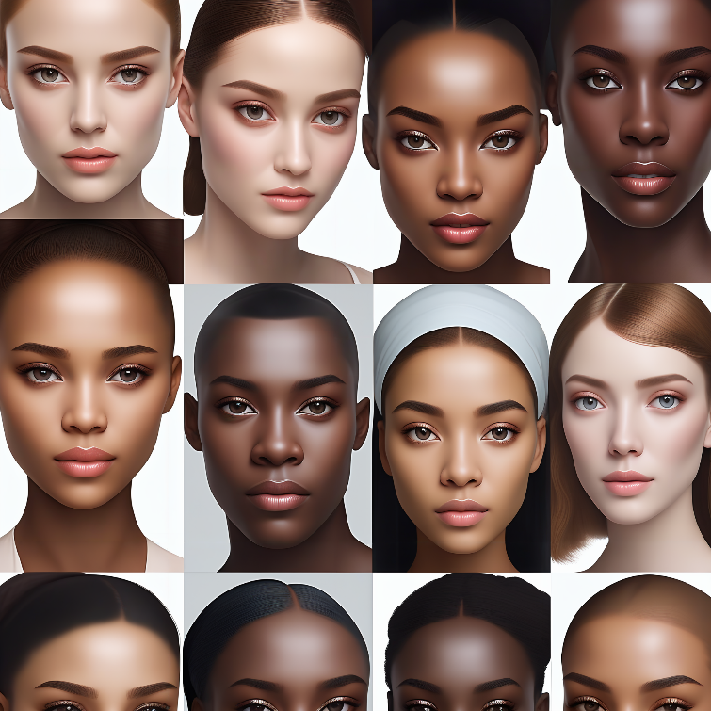

AGE: [select from 18 to 120] Maybe auto-filled based on site registration; finding matches use a slider for range]

HEIGHT: (profile creators use slider with feet and inches; finding matches use slider to set range)

WEIGHT: (profile creators use slider in pounds; finding matches use slider to set range)

BODY TYPE: [profile creator browse images and select only one; finding matches select up to 5]

**SEX ORIENTATION:** [Profile creator select one; finding matches select up to 7] drop list

STRAIGHT, GAY, LESBIAN, BISEXUAL, PANSEXUAL, ASEXUAL, SAPIOSEXUAL

**HOUSEHOLD**

Residing Status: [Buying, Renting, Owned, Contributing, Temp stay] Profile creator select one; finding matches select up to 5

Adults in house: [Live alone, Live with adult(s), Roomate, Taking care of Parent(s)] profile creator select one; finding matches select up to 4

Children: [No children, Have infant(s), Have pre-teen(s), Have teenager(s), Have grown children] profile creator select up to 4; finding matches select up to 4

Number of children living at home [profile creator select from 1-10; finding matches use slider for range]

Indoor Pet: [Pet dog(s), Pet cat(s), Pet bird(s), Pet reptile(s), Pet rodent(s)] Select up to 5

Outoor Pet: [Pet dog(s), Pet cat(s), Pet bird(s), Pet reptile(s), Pet rodent(s)] Select up to 5

LOCATION: (profile creator use registration’s zip code or turn on Mobile location to update current zip code; finding matches use slider to select range of miles away)

[check box] Use my current mobile location zip code

[check box] Use my registered zip code

CURRENT RELATIONSHIP STATUS: [profile creator select one; finding matches select up to 7]

Single, Poly, Cheating, Married, Divorced, Widowed, Separated

RELATIONSHIP GOAL: [profile creator select up to 3; finding matches select up to 11]

CASUAL DATING, POLYAMORY (POLY LIFE), MARRIAGE, FRIENDSHIP, MONOGAMOUS RELATIONSHIP, FRIENDS WITH BENEFITS (FWB), LONG-TERM RELATIONSHIP, EXPERIMENTAL RELATIONSHIP, HOOK-UPS, NETWORKING OPPORTUNITIES, OPEN RELATIONSHIP

**ALCOHOL/DRUG USE**

ALCOHOL USE: [Profile creator select only one; finding matches select up to 4]

No Alcohol use, Alcohol occasionally, Alcohol rarely, Alcohol at least 3 times weekly

CANNABIS USE: [Profile creator select only one; finding matches select up to 5]

No CBD use, CBD products occasionally, CBD rarely, CBD at least 3 times weekly, CBD medically

OTHER REC DRUG USE: [profile creator select one; finding matches select up to 3]

Other Drug use occasionally, Other Drug use rarely, Other Drug use at least 3 times weekly